Machine Learning Model Deployment with IBM Cloud Watson Studio

Phase – 5(Documentation)

**Abstract**

This project leverages IBM Cloud Watson Studio to develop and deploy predictive models for customer churn analysis in the telecommunications industry. By collecting and analyzing customer data, training machine learning models, and integrating them into operational systems, the project aims to proactively reduce churn rates and enhance customer retention strategies.

**Problem Statement**

Become a wizard of predictive analytics with IBM Cloud Watson Studio. Train machine learning models to predict outcomes in real-time. Deploy the models as web services and integrate them into your applications. Unlock the magic of data-driven insights and make informed decisions like never before!

**Problem Definition**

The project involves training a machine learning model using IBM Cloud Watson Studio and deploying it as a web service. The goal is to become proficient in predictive analytics by creating a model that can predict outcomes in real-time. The project encompasses defining the predictive use case, selecting a suitable dataset, training a machine learning model,deploying the model as a web service, and integrating it into applications.

**Dataset Link**

**Project features**

1. **DATA COLLECTION AND PREPROCESSING.**

**Data Collection:**

The project's foundation is built on a robust dataset that encompasses historical loan

application data from a variety of sources, including banks, credit bureaus, and other

financial institutions. This dataset is continually updated to reflect changing trends and

economic conditions.

**Data Preprocessing:**

Before the data can be used effectively, it undergoes thorough preprocessing. This

includes the identification and handling of missing values, outlier detection, and data

standardization. This meticulous data preparation ensures that the machine learning models

receive clean, reliable input for decision-making.

1. **MODEL TRAINING AND EVALUATION.**

**Data Splitting:**

The dataset is divided into three subsets: training, validation, and test sets. The training

set serves as the foundation for model learning, the validation set is used for model selection

and hyperparameter tuning, and the test set assesses the final model performance.

**Model Training:**

Model training is an iterative process where algorithms learn from the training data.

Adjustments are made to ensure a balanced trade-off between predictive accuracy and

fairness. The training phase involves significant experimentation and refinement to

achieve the desired outcomes.

**Model Evaluation:**

Comprehensive model evaluation is conducted using a battery of metrics, including

accuracy, precision, recall, F1-score, and ROC-AUC. The evaluation goes beyond accuracy

and extends to fairness metrics to ensure that our automated system is transparent and

minimizes discrimination.

1. **DEPLOYMENT AND USER INTERFACE**

**Deployment Process:**

Model deployment is executed through IBM Cloud Watson Studio, providing a scalable

and reliable platform for serving predictions. The process includes converting trained

models into a format suitable for real-time loan approval decisions. Our deployment

infrastructure is designed to support increased demand while maintaining efficiency and

reliability.

**User Interface Design:**

The user interface is meticulously designed to ensure a smooth and transparent

application process. It simplifies data submission, reduces documentation requirements, and

integrates real-time feedback mechanisms. The interface empowers applicants to make

informed decisions about their loan options and improves their overall experience.

**4. TESTING AND VALIDATION**

**Testing Procedures:**

Rigorous testing is conducted to ensure the accuracy and reliability of the system. This

includes sensitivity analysis to understand the impact of various factors on loan decisions

and stress testing to evaluate the system's performance under high demand. Ongoing

testing and validation processes are in place to maintain the system's reliability.

**PHASE 3:**

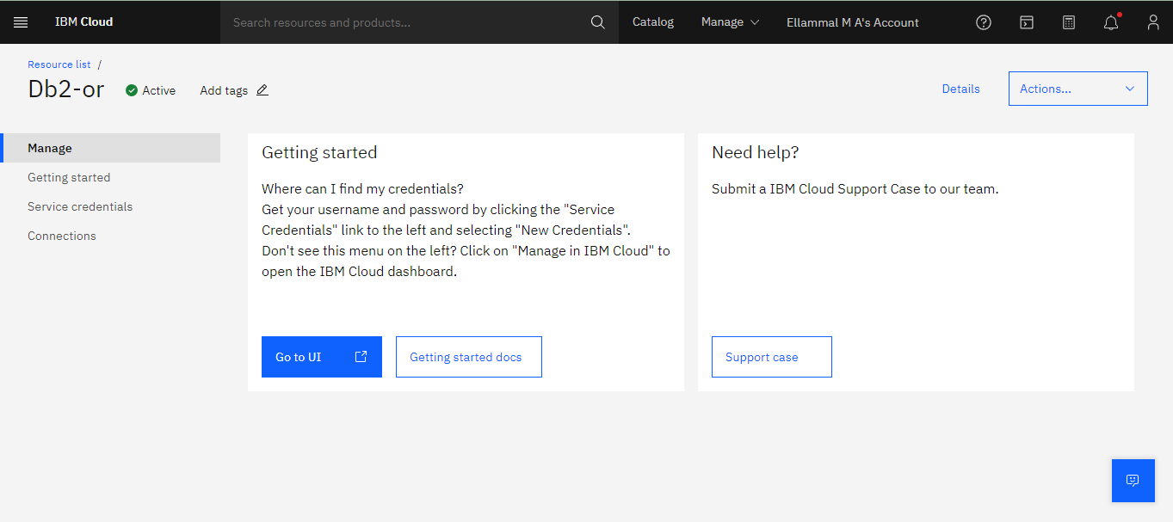

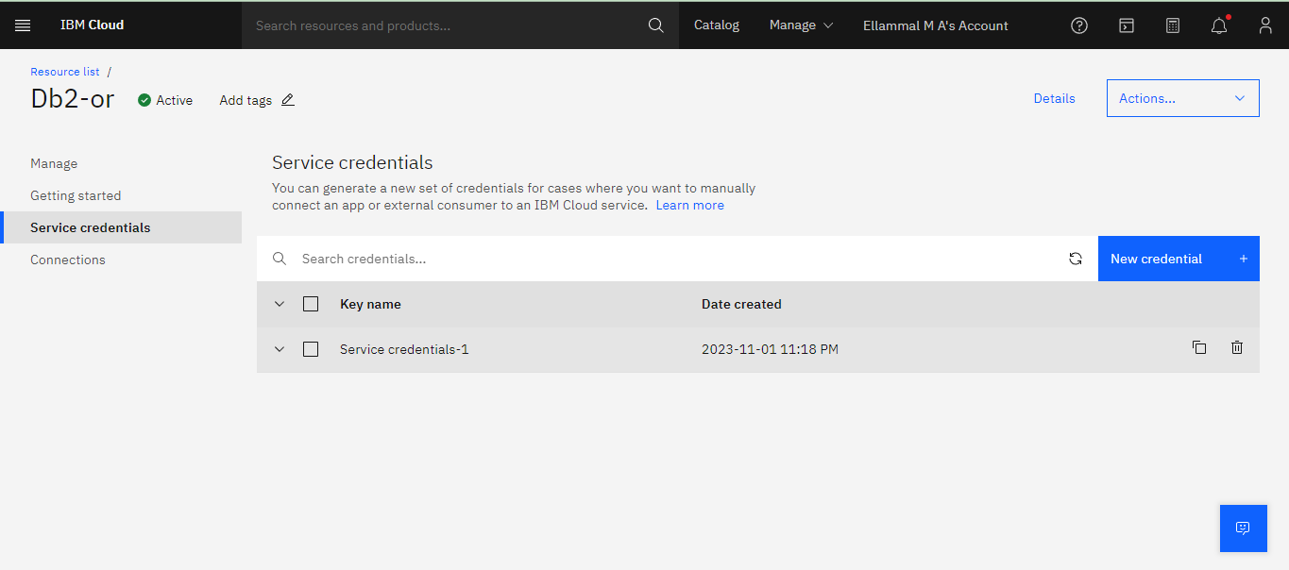

"-u",

"dbm63932",

"-p",

"W3KPfJv9swuf699o",

"--ssl",

"--sslCAFile",

"1dd14d0c-1b52-4f63-a606-53ecba28771d",

"--authenticationDatabase",

"admin",

"--host",

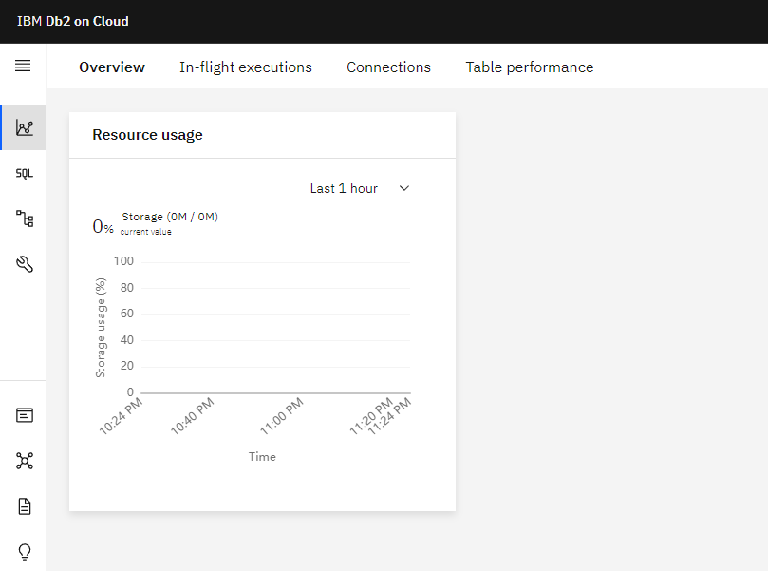

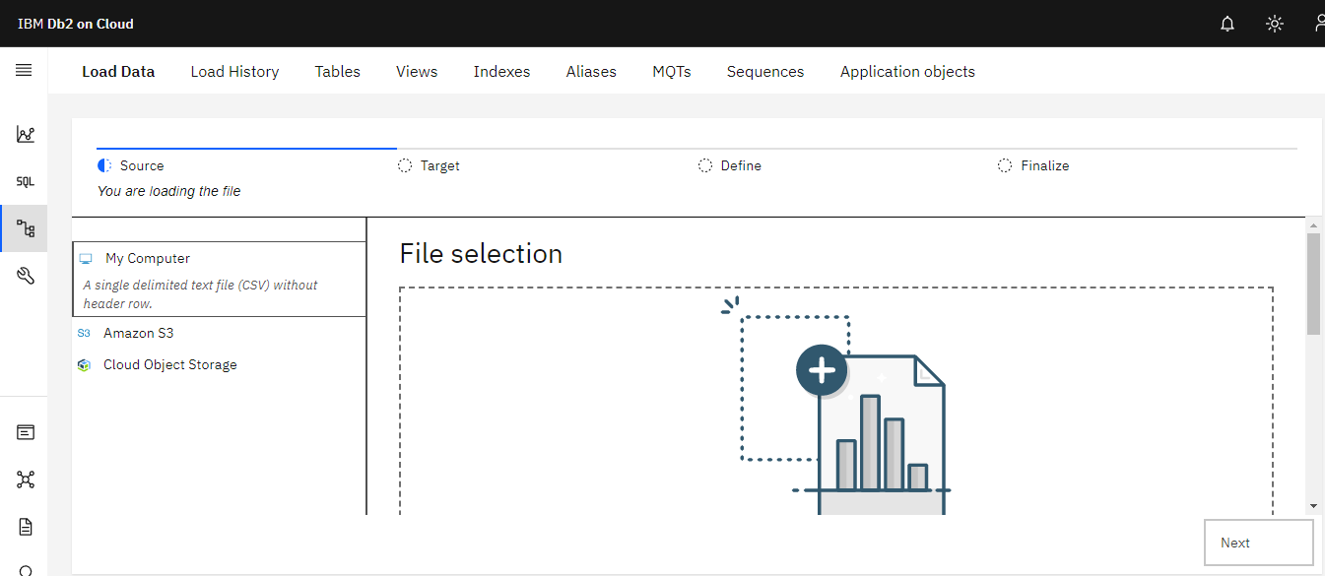

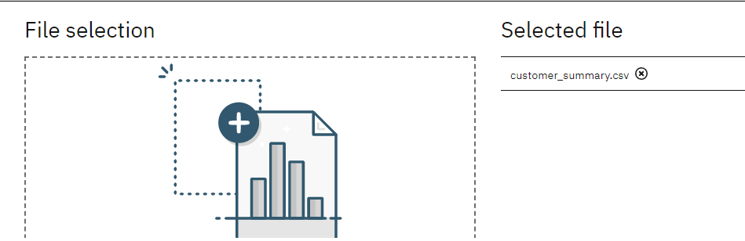

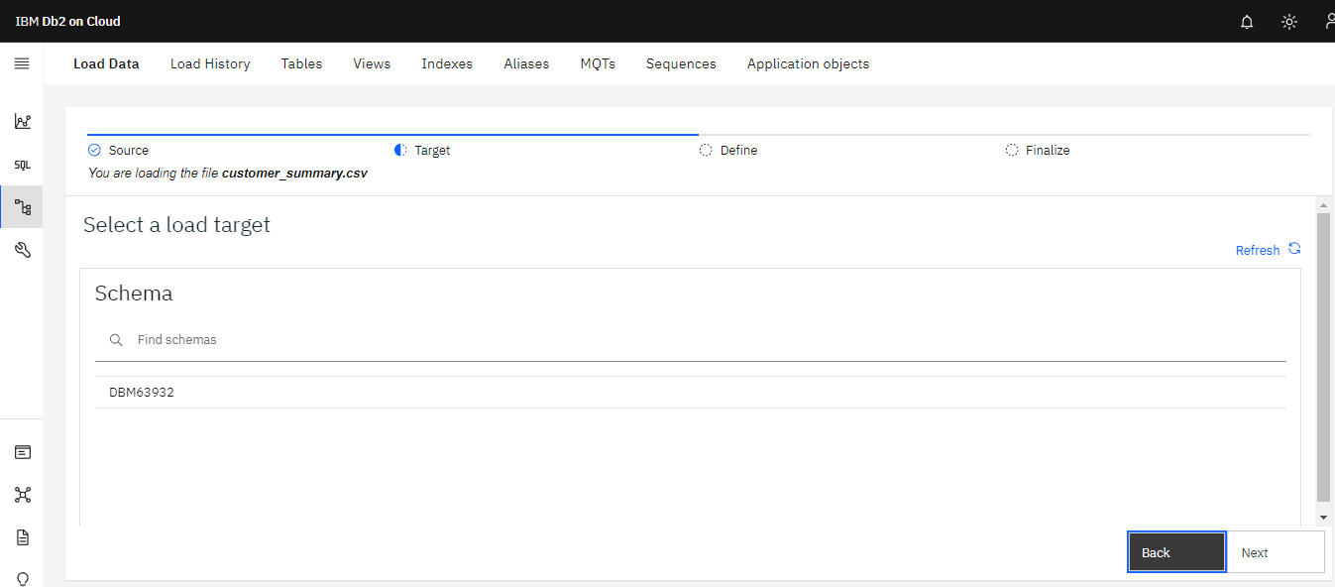

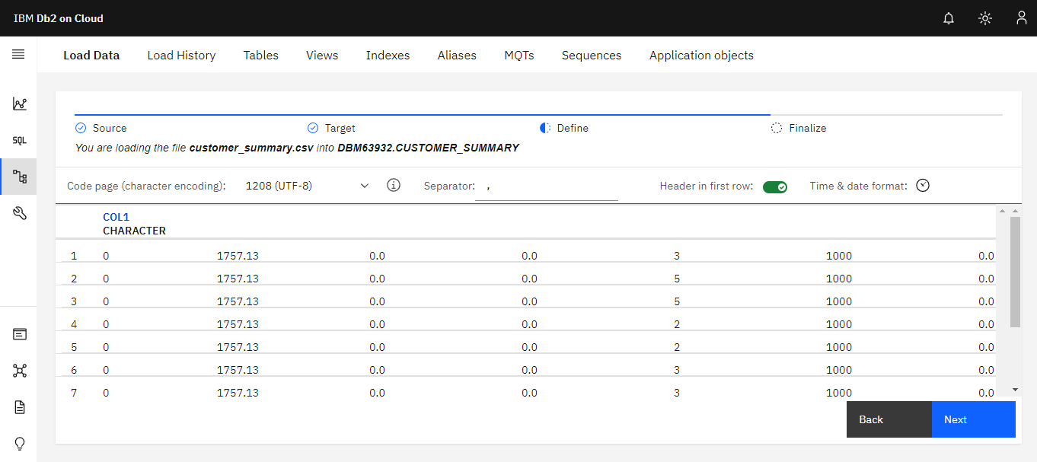

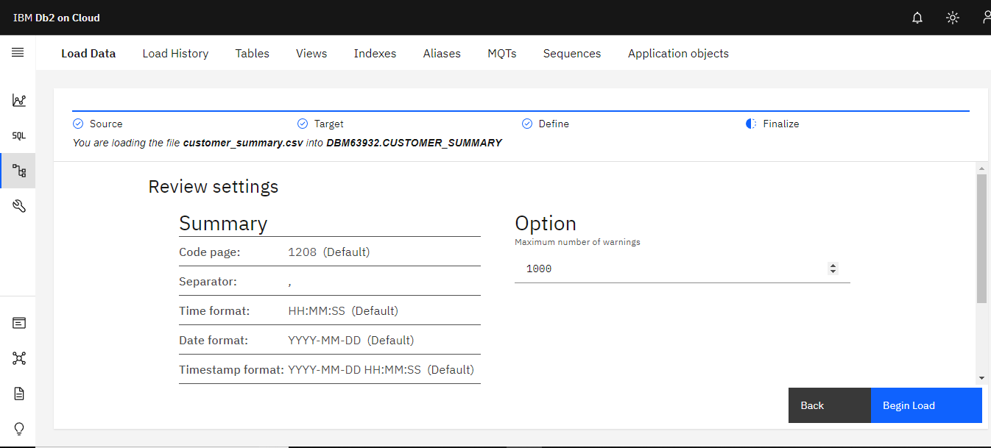

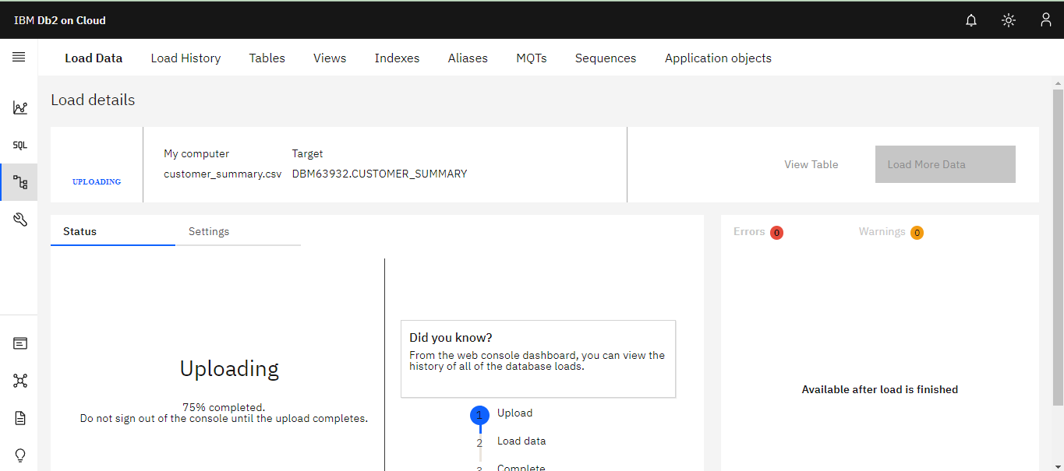

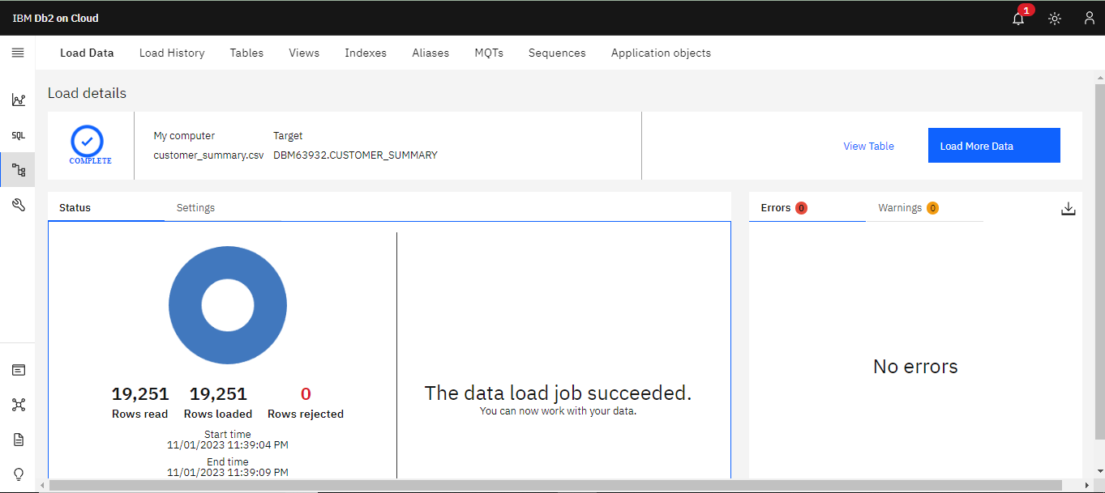

**PHASE-4**

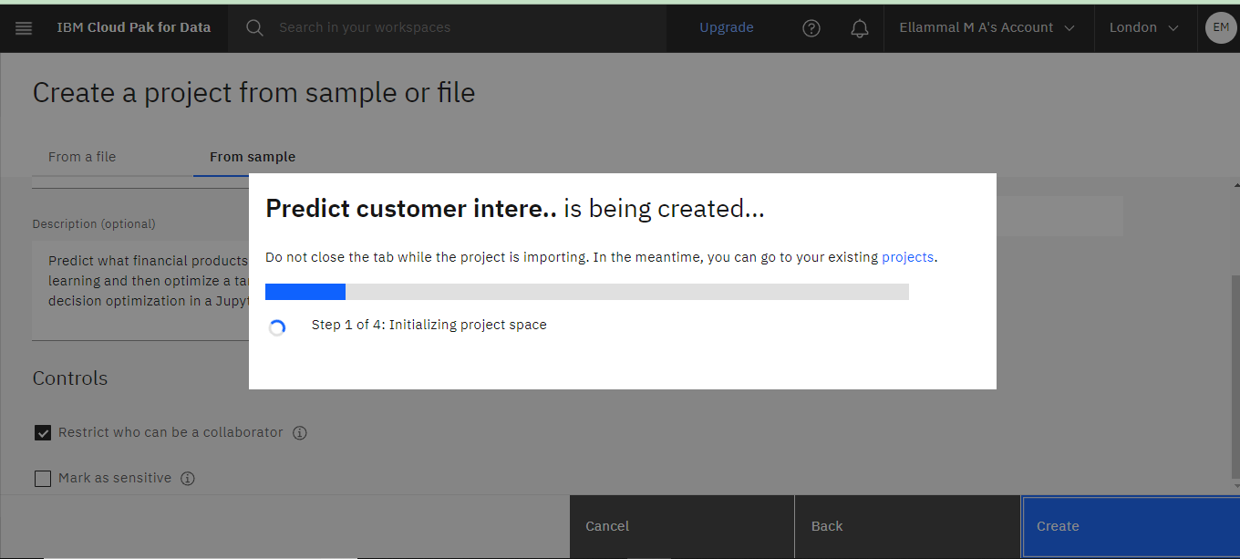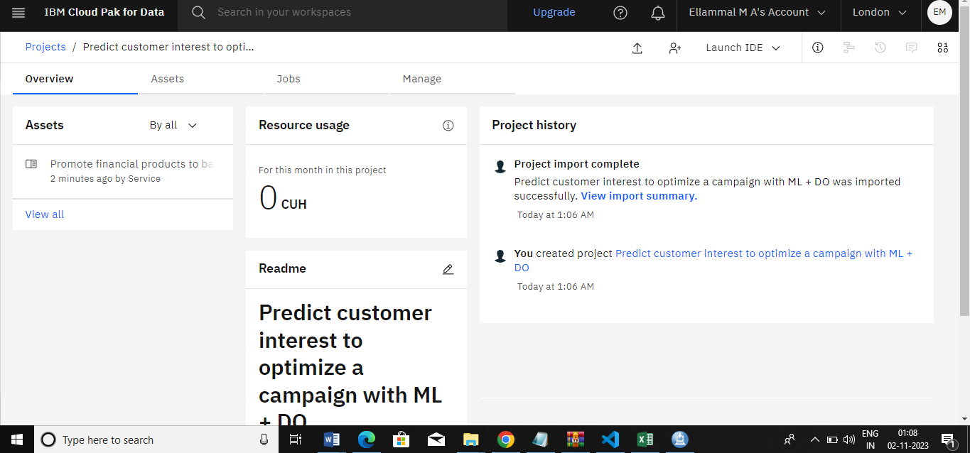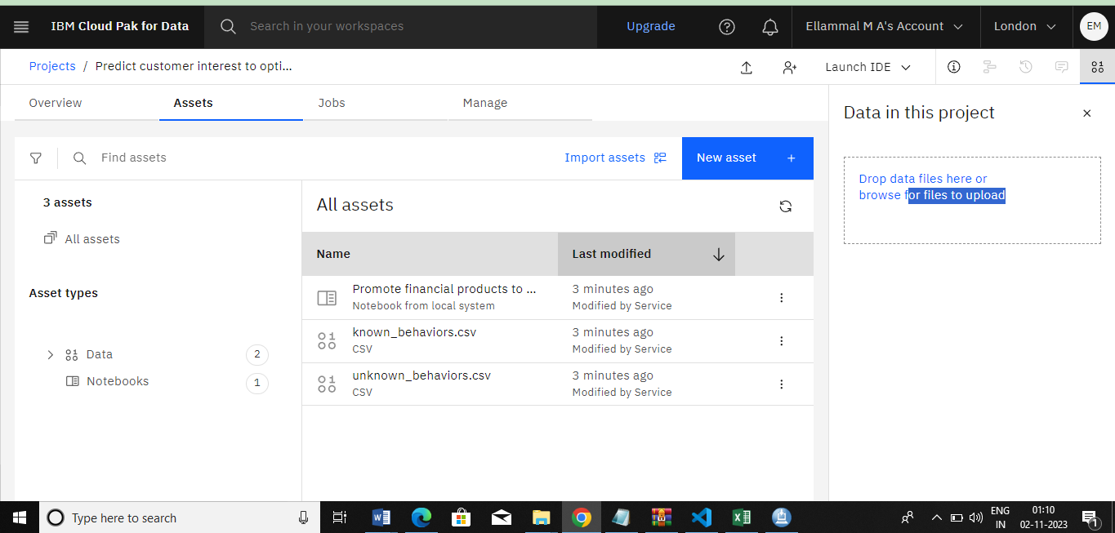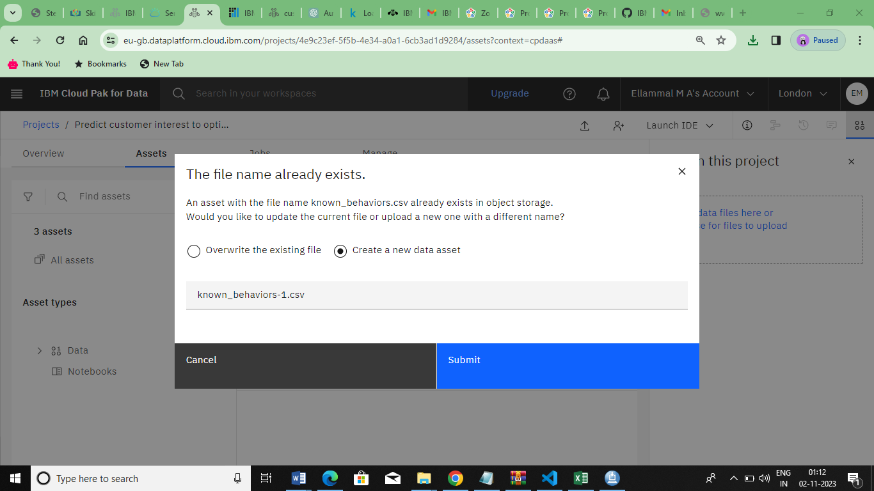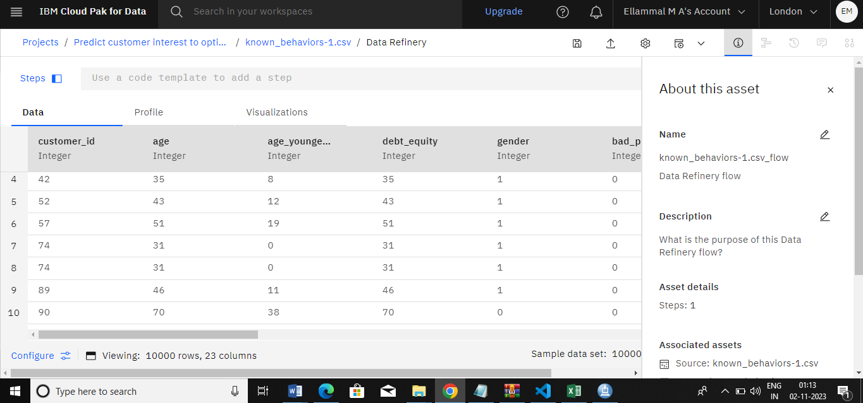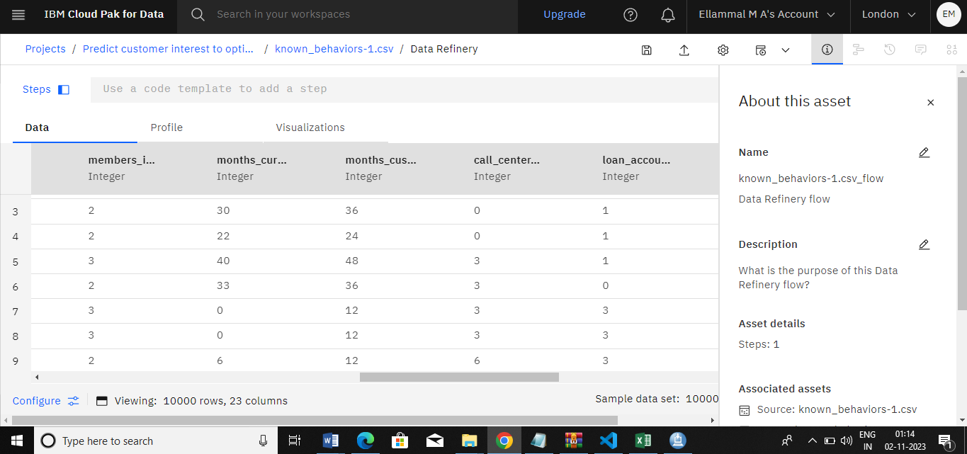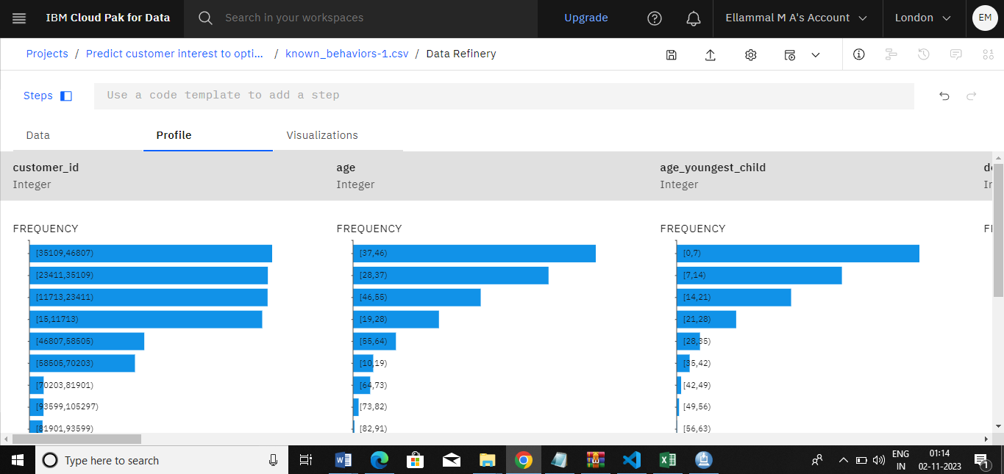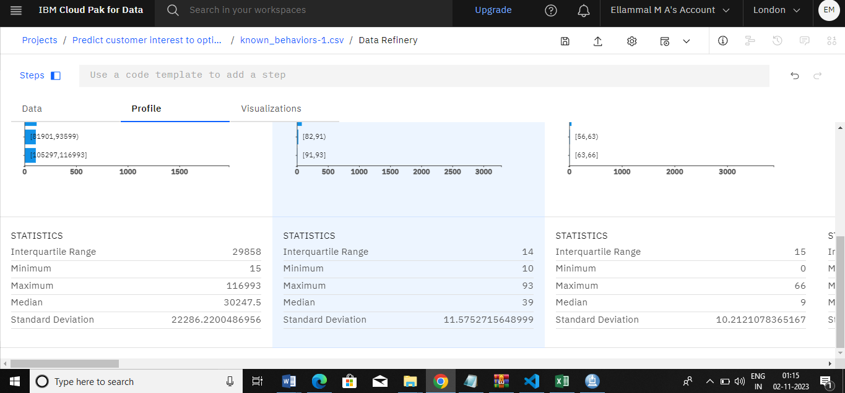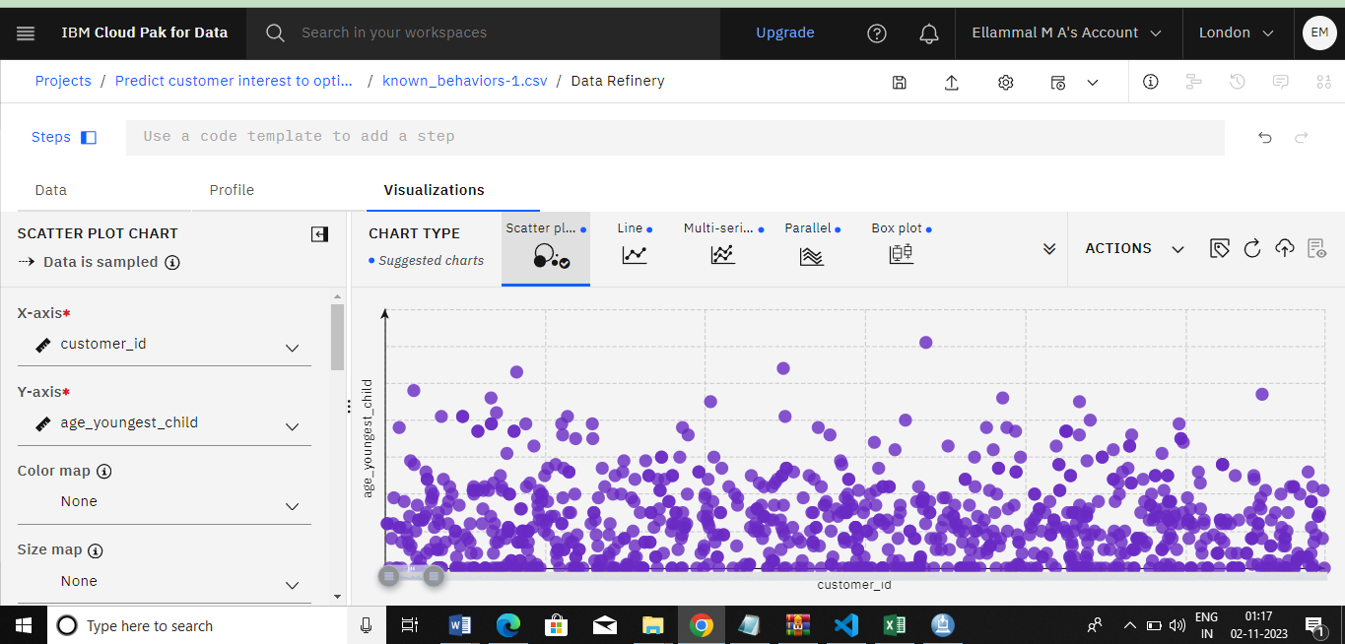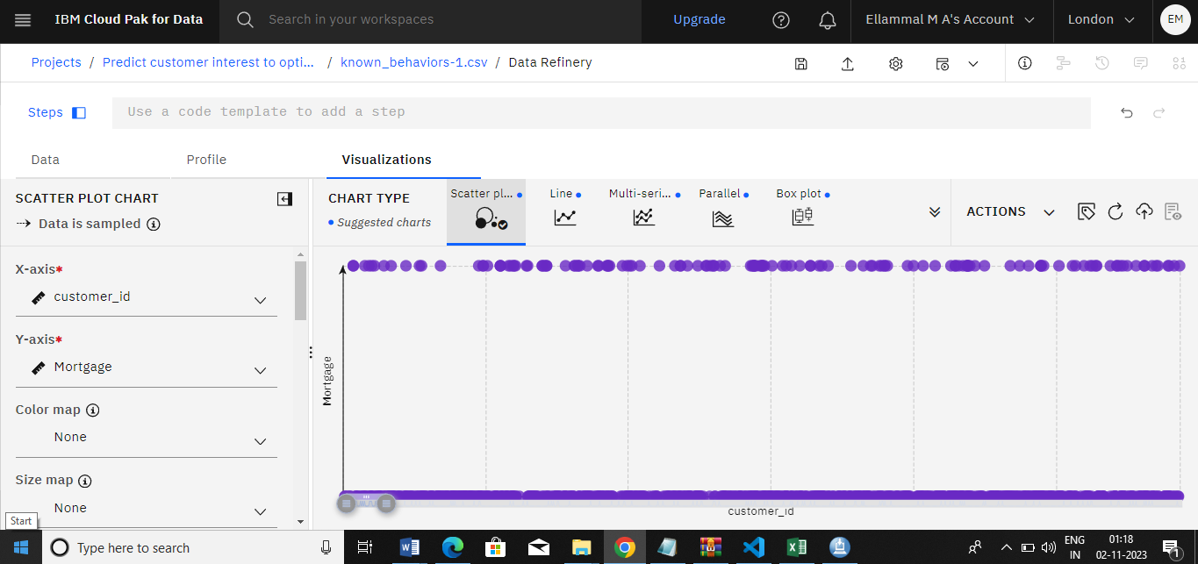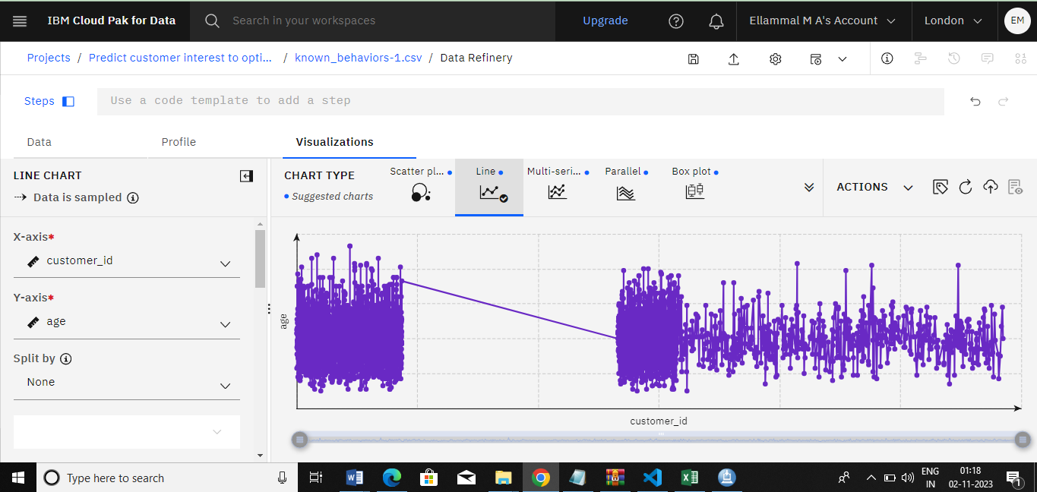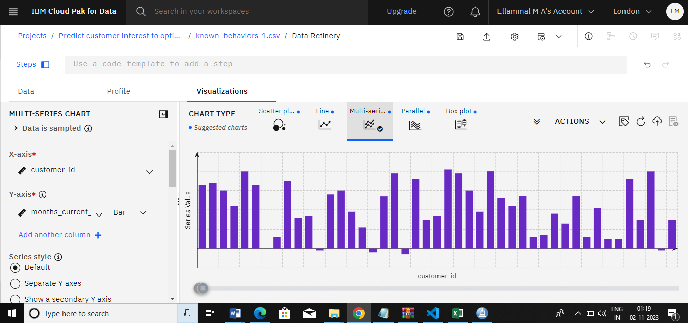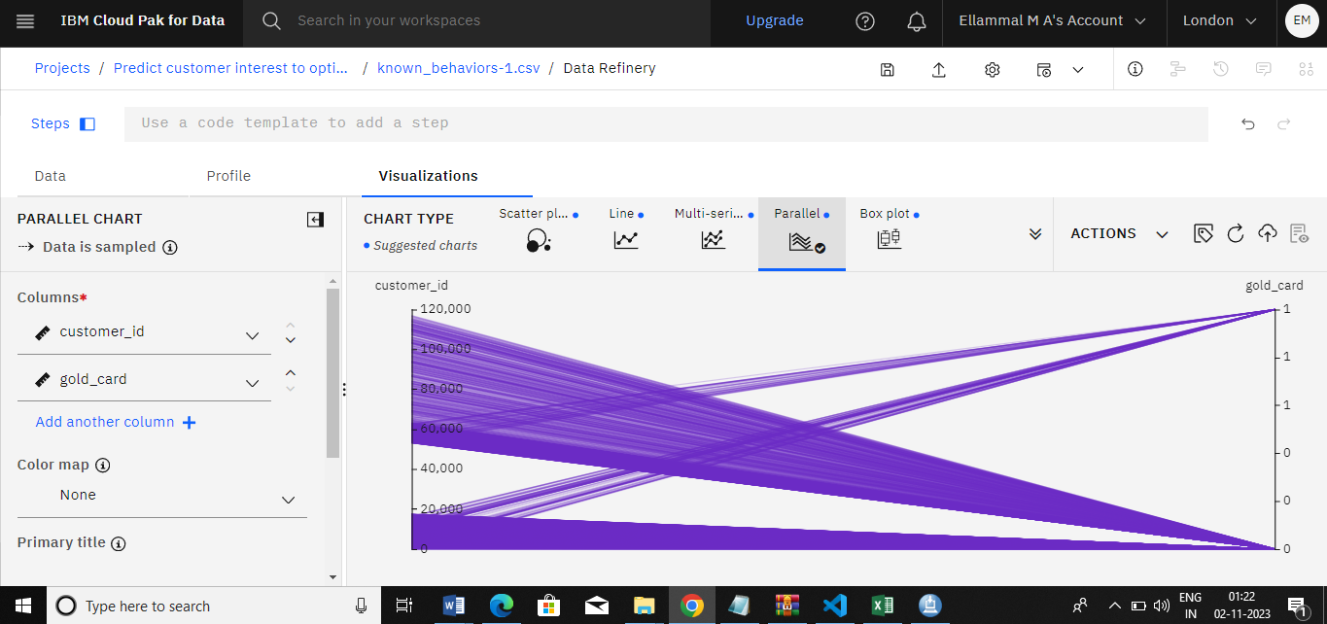

**Conclusion**

In conclusion, the application of advanced machine learning models for customer churn prediction in telecommunication companies represents a pivotal step towards fostering customer retention, optimizing business operations, and maximizing profitability. the synergy of data-driven insights, predictive analytics, and proactive customer engagement offers a compelling avenue for telecommunications companies to mitigate the challenges of customer attrition. By harnessing the power of data, implementing robust machine learning frameworks, and continuously refining predictive models, these organizations can not only identify at-risk customers but also tailor strategic interventions that lead to enhanced customer satisfaction and long-term loyalty, ultimately propelling them towards sustained success in an ever-evolving industry landscape.